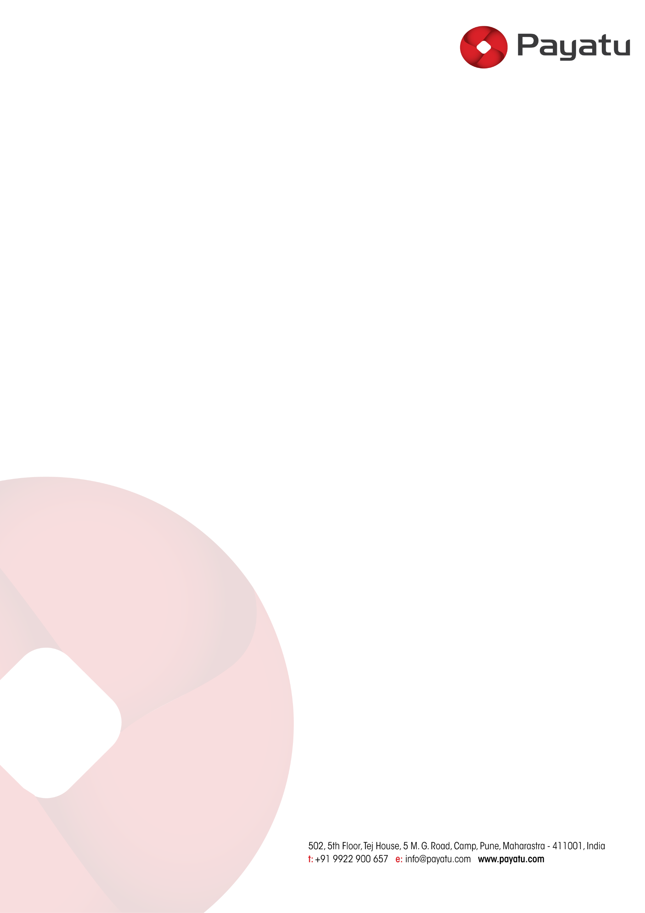 Date: 2023-07-28

**Goodie Bag Sponsorship Booth – Nullcon Goa 2023**

This document outlines the terms of the strategic alliance between **<** **Payatu Technologies Pvt. Ltd.>** registered at Behind Sea Scan Maritime, 307 - N, Air Vice Marshal, Airport Road, Pinto Marg, Chicalim- Vasco, South Goa, Goa, 403711 (Organizer) and Sponsor Name, registered at Sponsor Address ( Sponsor ) for Nullcon (an International Security Conference, Goa 2023), happening on 20 sep to 22 sep

**Payatu Technologies Pvt Ltd (“Host”) Obligations:**

Host will provide the Sponsor with the **Sponsorship Benefits** set forth in the Sponsorship Agreement (as described in the Sponsorship Brochure):

|  |  |
| --- | --- |
| Sponsorship Level | **Goodie Bag Sponsorship + Standard Exhibition Booth** |
| Sponsorship Fee | **$200 + GST** |
| Benefits:   * Add Benefit 1   {{ Add_another_benefit }}  *IMPORTANT: Host does not, in any scenario, share attendees’ contact details.* | |

* **Branding**: Hostgrants the Sponsor a limited non-transferable, non-exclusive, royalty-free license to use the Host’s logos solely to promote the sponsorship of the event, during the term only and in accordance with the terms and conditions of this agreement.
* **Sponsor Participation**: Host will register the Sponsor team 15 days prior to the event start unless discussed prior with the conference team. Exhibition booth staff also needs to have a valid conference pass, as we do not have only exhibitor pass option.
* **Supporting the Sponsor:** In performing its activities, duties, and obligations in connection with this contract, the Host will strive to promote and raise awareness of the Sponsor to assist it in achieving its objectives.
* The Host will keep the Sponsor informed as promptly and as reasonably practicable with respect to developments that might affect the Sponsor’s participation in the event.
* If for any reason, Host is unable to deliver any of the sponsorship benefits, the Sponsor will be informed as soon as reasonably practicable, and the parties shall agree aa on a good faith basis a partial refund for any fee paid in accordance with the reduced delivery of sponsorship benefits.

**Sponsor Name (“Sponsor”) Obligations:**

* **Sponsorship Fee**: The Sponsor shall pay the sponsorship costs to Host 100% in advance, within 30 days from the date of the invoice issued to the Sponsor (but in all cases, prior to the start of the event). Host can only accept payment via bank transfer. In the event of late payment, Host reserves the right (and the Sponsor agrees to pay) to claim a monthly interest of 5%.
* **Bank Details:**

Account Name: Payatu Technologies Private Limited

Account Number: 003905501791

Bank Name: ICICI Bank Limited

IFSC Code: ICIC0000039

SWIFT Code: ICICINBBCTS

Account Type: Current

Branch: Shivaji Nagar, Pune.

* **Branding & Deliverable Deadlines**: The Sponsor hereby grants the Host a non-transferable, non-exclusive, royalty-free license to use any such logo, artwork, or other advertising and marketing material as set forth in the Sponsorship Agreement. Sponsor Branding is to be used solely and strictly for the purpose of promoting, marketing, and advertising the event and the Sponsor’s involvement in the event.
* The sponsor logo and branding on the Nullcon stage, print and deliverables would be of only the main sponsor and not of its partners or subsidiary companies/associates.
* Sponsor shall, within 10 days of signing the Sponsorship Agreement (not later than 20 days prior to the event start) supply the Host with the branding materials in a suitable format. Host will publish it on the conference webpage within 5 days of receiving it.
* Sponsor shall be solely responsible for all costs incurred relating to the Sponsor’s attendance at the Event (for instance, but without limitation, any travel costs, accommodation costs, or screen/tv rental costs).
* **Brochure advertising artwork (if applicable)**

Deadline:     15 days before the event

Size:             Width: 13.68 cm             Height: 15 cm

* **Job openings (if applicable)**:

Deadline:     20 days before the event or discussed otherwise

Use this template:

Company Name:

Job Title:

Location:

Job Description: (75-100 words)

URL:

Reference/HR Contact:

* **Exhibition booths**:

If exhibition booth is included in the sponsorship benefits, the timing for the booths will be from 9:30 am to 5:30 pm on both conference days.

Setup of the exhibition booth can only be done on the evening prior to the Day 1 of the conference, after 6:00 pm, unless discussed prior.

Excluding any acts for which the Host or its employees are directly responsible, the Host is not responsible for the loss or theft of any items during the exhibition timing.  
  
Nullcon is dedicated to creating a safe and welcoming environment to everyone. Hence, we request everyone at the event from refraining from any illegal, demeaning, discriminatory behaviors or any speak, or behaviors can be constructed as harassment, intimidatory or abuse. If found, Nullcon has the right to report to govt authorities and ban the attendee form the/future events and not liable for any damages or refund in any case.

* **Marketing materials and swags** will only be accepted by the Host and the Hotel Venue Staff 5 days prior to the start of the event. Please do not deliver anything earlier than that.

**Postponement, Cancellation, and Force Majeure:**

Host shall not be deemed to be in breach of this Agreement or otherwise liable to Sponsor for any failure or delay in performing its obligations under this Agreement because of an event or series of connected events outside of Host’s reasonable control (“Force Majeure Event”). In the event of Force Majeure, Host may cancel, amend the date of the event, or change the venue (which may include the platform hosting the event virtually), or otherwise alter the event.

**Term & Termination:**

Nullcon reserves the right to use images taken at the conference & trainings with your photograph and videos clips for future marketing materials.

This Agreement shall take effect on the date that the last party signs the Sponsorship Agreement and shall continue until the completion of the event (Term).

This Agreement shall terminate automatically on the expiry of the Term.

|  |  |
| --- | --- |
| **Sponsor Name** | **For Payatu Technologies Pvt. Ltd.** |
| Sign: | Sign: |



Name: Name: Harshit Mahajan

Designation: Designation: Head of Events - Nullcon